Amanda Woo
25c Corbel Street, Shelley, 6148 · 0401 307 059
w.karyan@gmail.com · www.amanda-woo.com
Marketing Officer experienced in applying digital solutions and implementing successful strategies across platforms to optimise customer experience and business growth. My involvement in multiple start-up companies allowed me to utilise and build my skills in WordPress, social media marketing and Google advertising.
I have the desire to enhance my marketing expertise through exposure to new projects to apply business growth strategies on a larger scale. I am confident that I can bring forward my skillset to the Marketing Executive role in Z1Z.

Experience

JULY 2021 – Present

Marketing officer, Ziksu Capital LTD
- Liaised with external agencies to ensure website is and coded according to company requirements.
- Created website design and concepts to be provided to external agencies for coding.
- Lead designer of company promotional materials, including presentations, booklets, flyers, business cards.
- Execute and manage digital branding campaign at Westfield shopping centres.
- Lead creator of banding guidelines and templates for the company.
- Developed Facebook ad strategy that increased follower count by 450% in 6 months.
- Manage, capture, and edit content shoots for digital and print media.
- Designed, manage, and executed social media strategies across LinkedIn, Instagram, YouTube, Twitter, and Facebook.
- Designed over 500 app screens for product prototype collaborating with internal teams to reach product launch deadline
- Manage ZikZone club management product reveal, which includes video creation, copywriting, booklets, and social media content to increase the number of club signups.

Aug 2019 – July 2021

Marketing officer, realteachers pty ltd
Playing an important role in a start-up company allows me to wear many hats in the organisation, which I have listed below.

Website Developer
- Designed and developed an SEO-integrated website that increased website visits by 200% in 2 months.
- Developed website solutions that automated the company’s recruitment process.
- Designed website concepts and developed branding for the company and its subsidiaries.
- Produced custom Wordpress theme and developed custom blocks, panels and content based on functional requirement.

Digital Marketer and Content Producer
- Developed Facebook ad strategy that increased recruitment candidates by 150%.
- Filmed, edited and directed 10+ videos for social media platforms and internal training.
- Designed and managed email marketing templates and campaigns with Mailchimp.
- Designed and executed social media strategies across LinkedIn, Instagram, and Facebook.
- Lead designer of company promotional materials (including booklets, flyers, business cards).

Events Coordinator
- Hosted and designed 10+ online and in-person seminars and youth events.
- Designed and facilitated youth training and events which increased client intake by 30%.
- Managed client relationships by conducting calls, emails, and meetings.

Jun 2019 – jul 2019

Marketing and content producer (intern), Groundswell group
- Implemented a re-branding strategy across 3 businesses, conducting consumer research and competitor analysis.
- Published blogs as part of the SEO strategy that resulted in an increase of website traffic by 20% in 4 days.
- Managed 6 social media accounts using Sproutsocial.

Education

2017 - 2018

Masters of business administration (Global), curtin university australia

2014 - 2016

Bachelor of commerce - international business, curtin university australia

Certificates Referrals

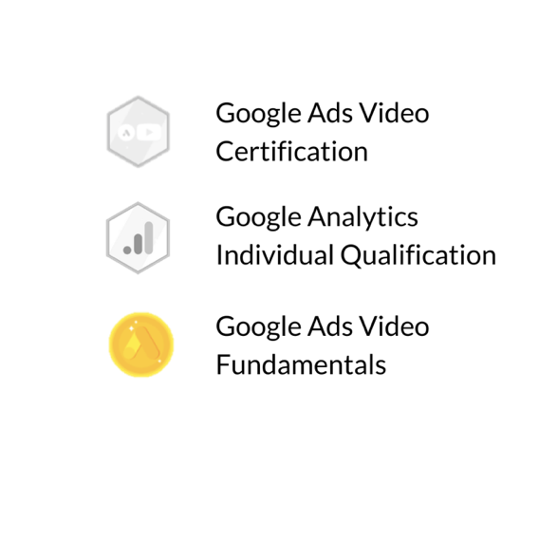
Google Ads Video Certification

Google Analytics Individual Qualification  Google Ads Video Fundamentals    Adobe Photoshop Certificate - Netmedia    Adobe Indesign Certificate - Netmedia    Adobe Illustrator Certificate - Netmedia | *References to be made available upon request

